I AM DOING MY NOTES AND THEN WRITING FROM WINDOWS CMD

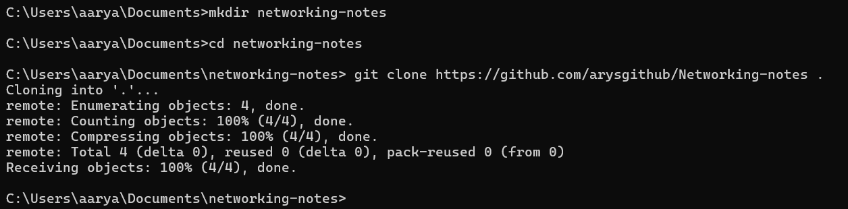

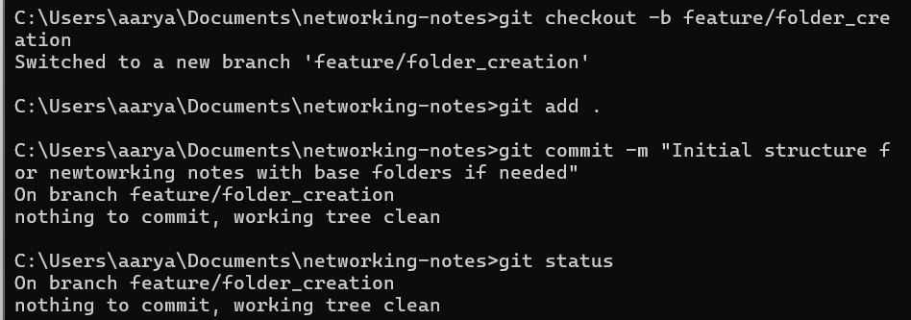

Then tried to push to GitHub – and then logged into my GitHub

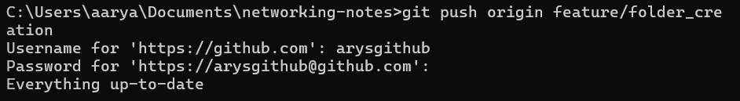

But never pushed the empty files – you have to make sure they have something in them to push so I made a conventional empty file called .gitkeep until I add real content to the folders. In the meantime it should push

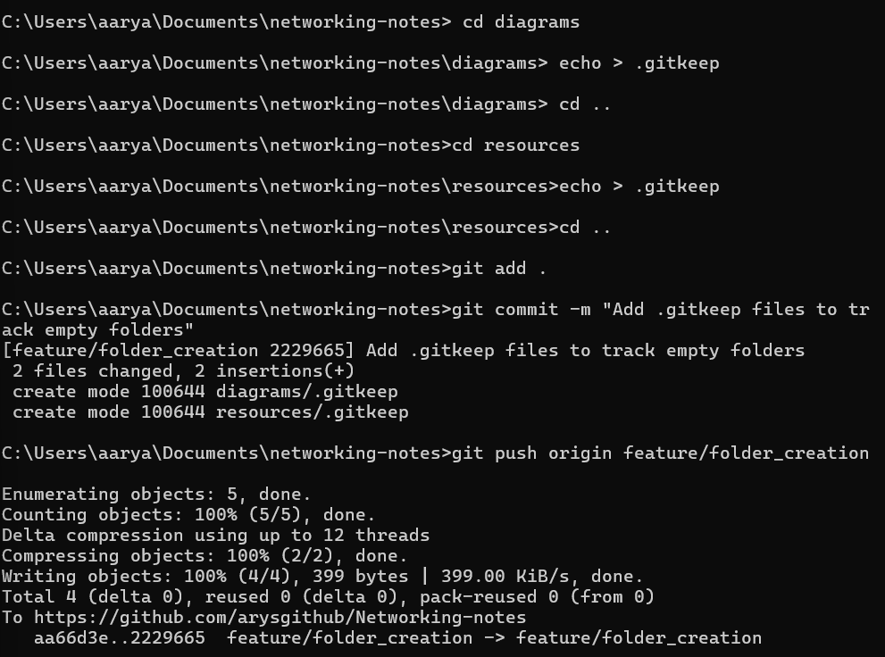

COMPUTER NETWORKING COURSE

By <https://www.youtube.com/watch?v=IPvYjXCsTg8&list=PL9gnSGHSqcnoqBXdMwUTRod4Gi3eac2Ak&index=3> - **Computer Networking Full Course - OSI Model Deep Dive with Real Life Examples**

[](https://www.youtube.com/@KunalKushwaha)

[Kunal Kushwaha](https://www.youtube.com/@KunalKushwaha)

# How it all started – THE BRIEF HISTORY

Internet is a connection of computer networks on a global scale.

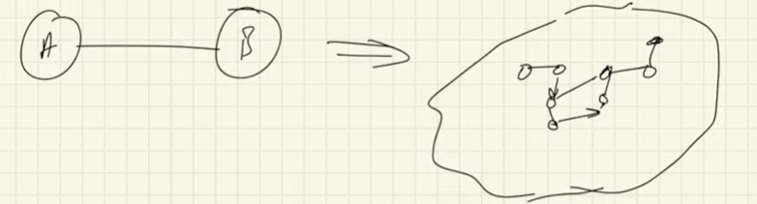

Code war USA and Soviet Union – who launch first satlite – Russia won in 1957. USA launched first program ARPA – Advanced Research Projects Agency – to do scientific discoveries to have USA always on top - developed communication techniques called arpanet – 4 places where computers were in different locations MIT, standford, UCLA, Utah uni. Now they could communicate -they used TCP. More computers and lcations so TCP/IP

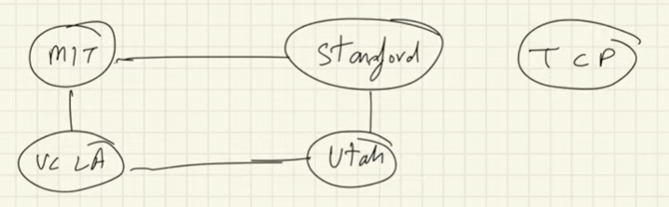

A PROTOCOL – the rules/steps and regulations required to perform an operation over the internet – eg sending a file via email or Encrypting a file and sending it. Eg TCP, UDP TCP/IP, SMTP.

Arpanet - Wanted to send a research paper with links to other research papers – ie need a way to click the link to direct me to another research paper -> leads into WWW – built by TIM Burners who developed the WWW – a project that stores these documents and access the documents and links via WWW.

WWW – this is an information system where documents and their resources are identified by uniform resource locators (URLS) which may be interlinked by hyperlinks and are accessible over the internet.

Here is the first ever WWW:

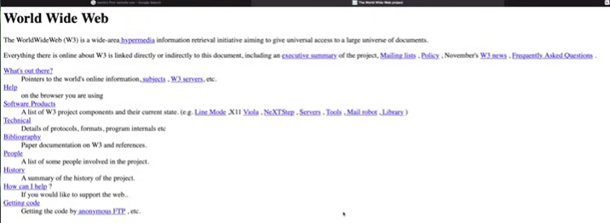

This is published by web servers.

How do you search for something using WWW – you couldn’t you could just move from hyperlink to hyperlink – so then search engines were created eg Yahoo(one of the very first), Google. – now everything has developed and is continuing eg Web3 etc

Who writes the protocols and controls and then creates new rules- THE INTERNET SOCIETY – how to make submissions – do by RFC – request for comments and give your ideas that you would like to add to the internet or something. Internetsociety.org

# CLIENT SERVER ARCHITECTURE

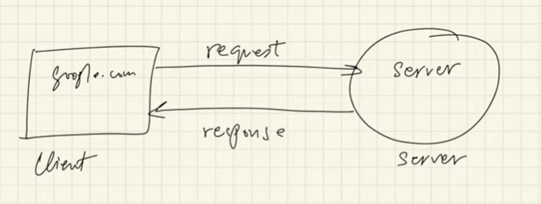

Sever – a system that controls your host website, Server must be high availability eg youtbue server -it will have many servers to prevent crashing – the servers are stored at Data centres – high upload speed, static IP addresses (don’t change), very good connections

In your cmd you can do - 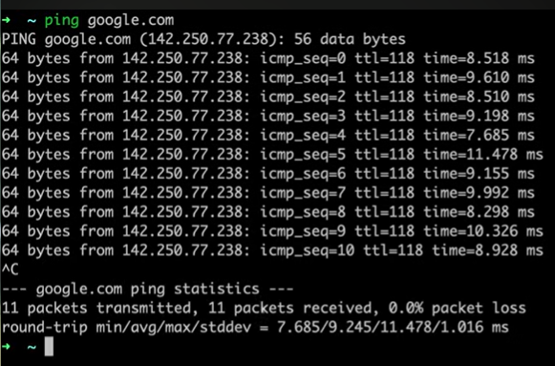 every packet is 64 bytes and the ip address of the server and then the sequence number and time. The entire time is known as ping time – you cannot adjust the ping time

Client and servers are have processes to run.

Your computer (CLIENT) sends a request to the server to access eg googl.com – then server responds back to the client with whatever is requested.

Your own computer can act as a SERVER AND A CLIENT – especially when you are a Local HOST

Every county is connected VIA optical wires connected under the sea

You can inspect the web page, and you can see the network information and all the processes and protocols that happen to create the web page.

# Peer to Peer Architecture

P2P - Applications or devices connected to one another. No one dedicated server, you can scale this very rapidly a decentralised network. Every computer is a client and server

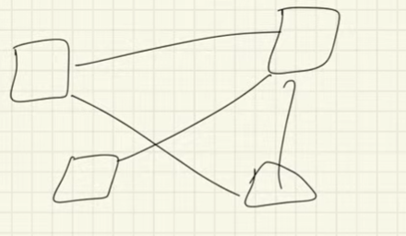 - you can have a hybrid peer to peer with a centralised system.

# PROTOCOLS

Protocols - the rules/steps and regulations required to perform an operation over the internet

There is different protocols for different layers

TCP – Transmission control protocol – ensures data will reach its destination and will not be corrupted on its way

UDP – User Datagram protocol - not all data may be reaching its destination eg video call (some pixels lost), stateless connection

HTTP – Hyper text Transfer Protocol – used by WWW and defines format of the dat being transferred between web clients and servers

HTTPS - Hyper text Transfer Protocol SECURE – used by WWW and defines format of thedata being transferred between web clients and servers securely eg utf-8

Web protocols for TCP/IP: in application layer

* HTTP/S
* DHCP – dynamic host control control – allocates Ip addresses to network and devices
* FTP – file transfer protocol
* SMTP – simple mail transfer protocol for sending emails
* POP3 & IMAC - used to receive emails
* SSH – login into someone else’s terminal and computer and take control
* VNC – virtual networking computing – graphical control
* Many more

Outside of tcp/ip

* Telnet – terminal emulation that enables a user to connect to a remote host or device using a tellnet client USUSALLY PORT 23 – manage an account or device remotely
* UDP

### Types of HTTP methods(tell server what to do):

Inspect network refresh

GET - requesting data

POST – I am a client and I am giving something to the server eg password

PUT – put data at a specific location

DELETE – delete information

### Status codes / ERROR CODES

200 – successful request

404 -couldn’t find it

400 – bad request

500 – internal server error

1 X X => informational category

2 X X +> success codes

3 X X => redirection codes

4 X X => client error codes

5 X X => server error codes

### COOKIES

Http is stateless – whenever you go back onto the site then it will think you a new user – but this state saving behaviour Is there this is due to COOKIES

Cookies – is a unique string or user value.

–it is a file stored on the clients browser – a cookie is set on the fist time you use a site and then the next time you go to use the site again the saved cookie will be sent to the sites header so the server knows who the client is and searches the database to know who is the client.

In the interests you will see the set-cookies and you will see the expiration dates aswell.

3rd party cookies – cookies that are set for the urls that you don’t visit eg ads for other ads and they take and use your data – and you should block and understand these

## How email works

SMTP – simple main transfer protocol to send emails

POP3 or IMAP to receive the email

You want to send entire email and for data not to be lost – so it would definitely use TCP so it does not get lost. #

TO send emails

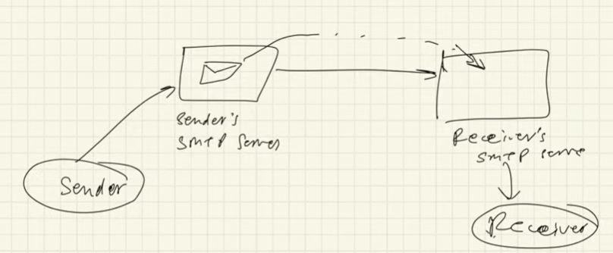

Take a look at the name server lookup command to find the name and ip address of the server

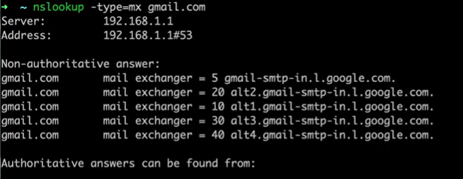

To receive emails – POP **Post Office Protocol** – port 110 – you client authorise the server to give you all the new available emails to you- so the POP server will transact and download the emails back to you. Then you can authorize it to do other things like delete . Note WITH POP if you delete an email on 1 device it will not be discoverable on the server and will not show on other devices

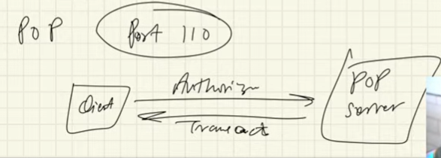

IMAP – get your emails – Internaet message access protocol – allows you to view your emails on multiple devices all your information will be kept on the server and will syncronyse with the server

## DNS – Domain Name System, URL Uniform resource locator

Use of a domain name eg google.com by use of the DNS to connect to the correct IP address and then it will connect to the server.

The databases are divided into different databases so they don’t get overloaded.

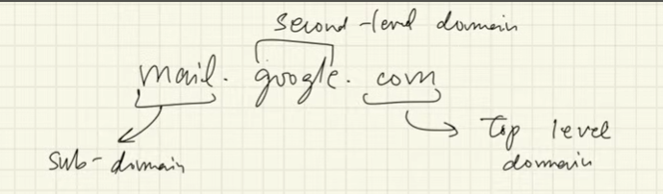

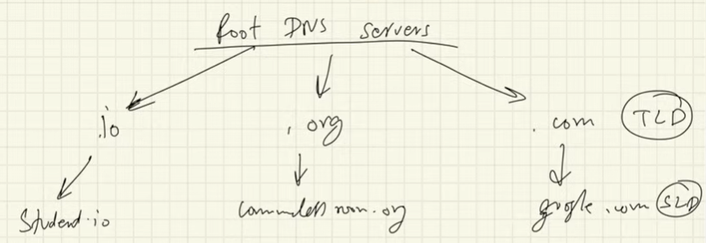

You can checkout who is maintaining the ROOT DNS at the website root-servers.org

ICANN73 register all the top level domains TLD

When you go to search for a site

1. Checks your own cache first to see if it ia in the computer
2. The local DNS server or ISP knows all your data even the incognito tabs that you have searched for
3. The .com will be checked for in the ROOT Sever if nothing it will go back to ISP then be sent to TLD top level domain and then TLD will return the IP address
4. Then the ISP will then return the full google.com server to be searched with its IP address to send back to the client for its search

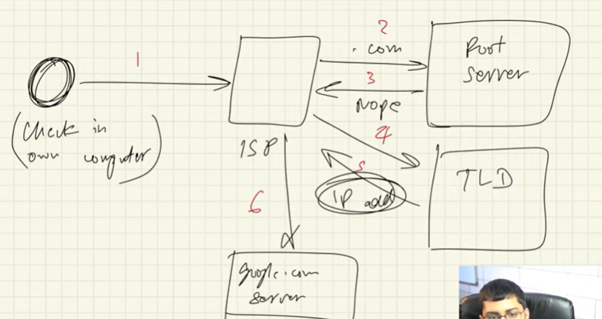

Dig command to see the results of the name searched :

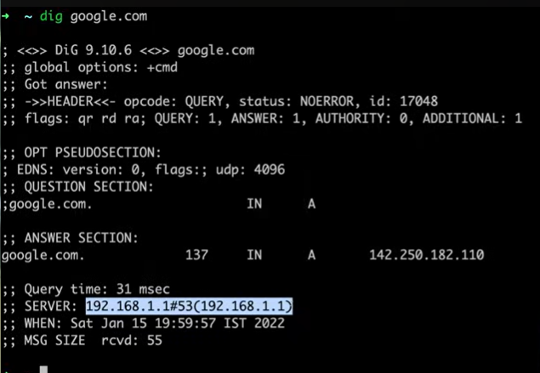

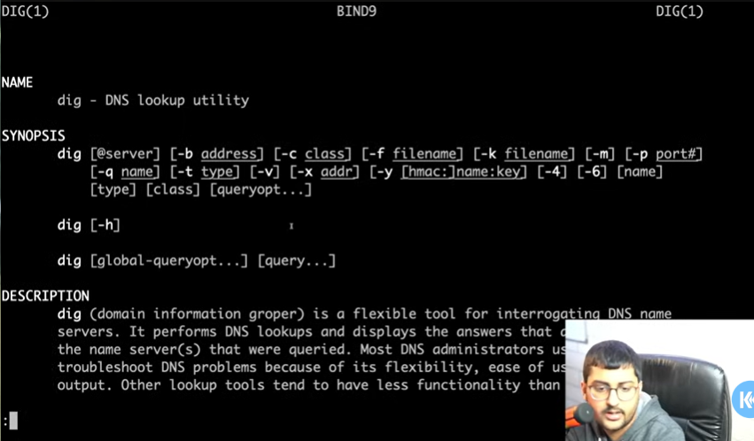

# How data is transferred and Ip Addresses

How is data transferred – in packets and

IP Addresses – every device has an IP address in the format X . X . X . X - each X has a value from 0 to 255. And different classes reserved Ip ddresses, local Ip addresses, MAC addresses

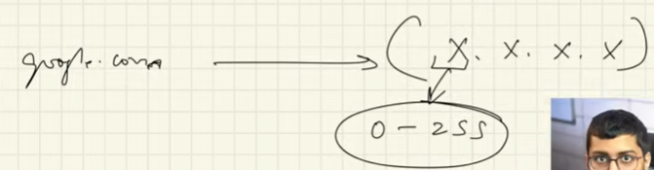

ISP -internet service provider gives you a router or modem with a global ip address – and all devices connected to the modem will have the same ip address from a global standpoint but within the modem there will be local ip addresses. How does it do this USING DHCP – dynamic host configuration protocol to assign the local Ip addresses with the global ip address but also manages more than that. When the D1 requests something from the internet it will go tp the modem/router which will then go to the ISP and to the internet and then the response will be sent back to the ISP then modem then to client. HOW IS IT DECIDED WHO HAS REQUESTED SOMETHING AND IS SUPPOSED TO RECEIVE IT ASWELL – the NAT network access translator – but which application in D1 made that request – IP address decides which device to send the data. But which application is decided by the PORT NUMBERS- that’s why each device has ip addresses and port numbers

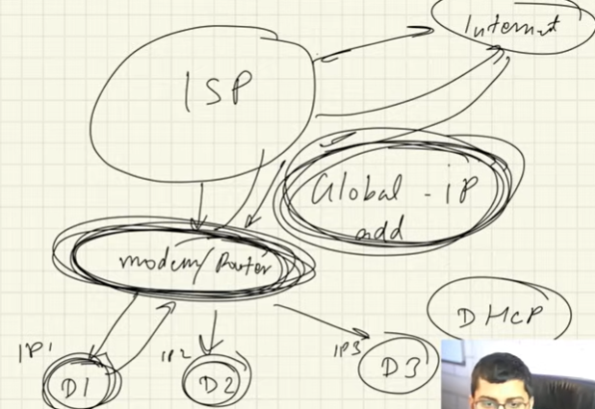

# Port Numbers

PORTS are 16 bits numbers basically Hexadecimal – 16 cells with 1 or 0 so the total port numbers possible are 2^16 port numbers available.

Web pages uses particular protocols eg HTTP – the port number for HTTP is PORT 80. Mongo DB = 27017. SQL = 1433

Well-defined ports are these reserved PORTS already.

PORTS from 0 and 1023 = have reserved ports so you cannot use them

Ports 1024 – 49152 are for applications only

Then remaining ports further from that you can use it for yourself now

How to measure the speed of ISP:

M b p s = mega (6 zeros) bits per second

1 mbps = 1 000 000 bits per second

1 gbps = 10 ^ 9 bits per second

1 kbps = 1 000 bits per second

More zeros means the connection speed is faster

UPLOAD – sending data from 1 device to another

DOWNLOAD – receiving data from another device ie downloading

You can random speed tests online which can check the speed of your connection

# Submarine Cables Map (Optical Fibre Cables)

Guided communication – connected through the wire

Unguided communication – communication connected by wifi or Bluetooth for example

What about country to county – the information will bounce off isp to internet to isp of another county – but at the base level each country has cables under the ocean which connect countries to countries: <https://www.submarinecablemap.com/>

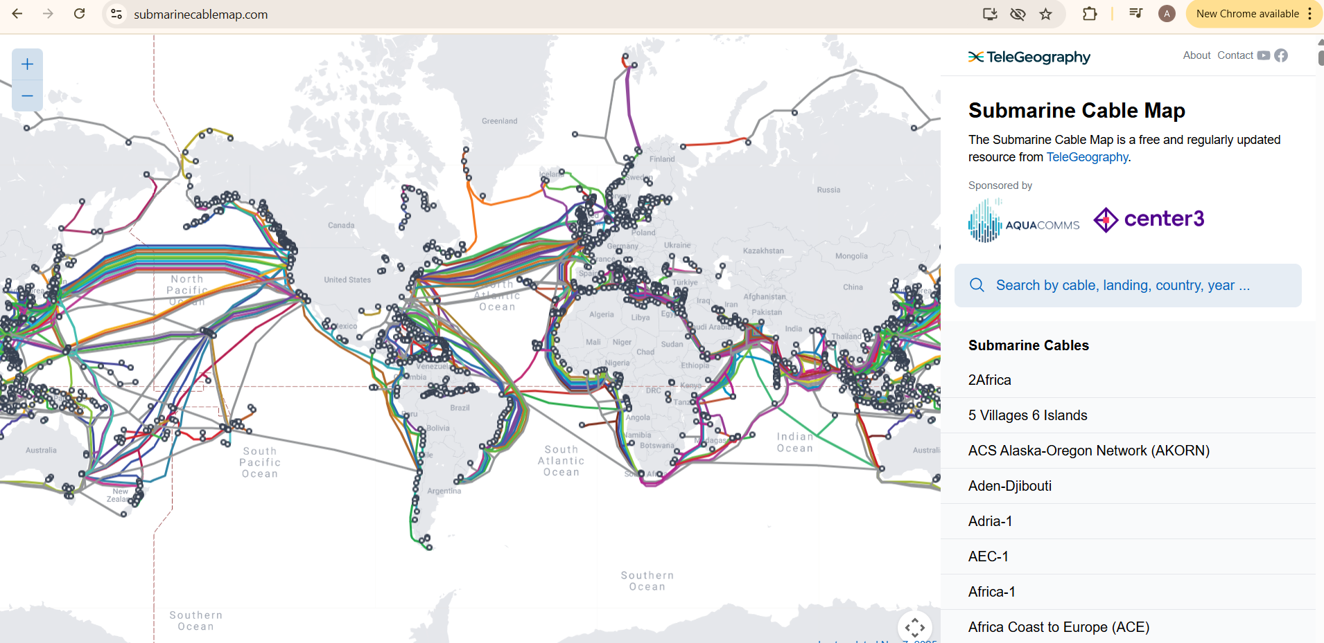

Who controls the big cables You'd have to research its on the internet for different companies and they give the ability to other entities and then to ISP so they can connect to each other eg more than28000 km of cable that connect many counties and continents. Google owns a lot of cables underground aswell:

The internet/cloud is not really the cloud its underground though cbales

Types of Physical cables – optical fibre cables, coaxial cables

Wireless – radio channels short range ie Bluetooth and Wif larger range 3G, 4G, 5G, LTE

Cables is faster than satellite

# LAN, WAN, MAN

Lan – local area network eg small house/office many devices in a small area

Connected using – ethernet cable – using bus topologies, network adaptors, wifi

Man – Metropoliatan area network which is across the city

Wan – wide area network eg across countries typically using optical fibre cables

1. SONET – synchronous optical networking – transfer data using optical cables
2. Frame relay – way for you to connect from WAN to the internet

THE INTERNET IS A CONNECTION OF ALL THE 3 ABOVE

# Modem/Router

Modem – used to convert digital signals to analogue signals and vice versa

Router – a device that routes the data packets based using their Ip addresses

TIER 1 – top ISP providers- in the UK include BT, Vodafone, Colt, Virgin Media, and GTT Communications, among others like Cogent, NTT, and Arelion

* **Core backbone providers**:

BT, Vodafone, and Virgin Media are major UK-based providers that also qualify as Tier 1 due to their extensive global networks and peering agreements.

* **Other global Tier 1s**:

Companies like [Colt](https://www.google.com/search?sca_esv=ed6f5ed44ddb5799&q=Colt&sa=X&ved=2ahUKEwi92aWz2OeQAxVaWUEAHSycMtUQxccNegQIPRAB&mstk=AUtExfC4ZpVUYFzTc_-kO2j3lCPCNNBFHBnEysVfVjBnGJbBCGW715huvc0WKIHTbJfgrPge8CYQlrR91BCH2llaSRGkRfd9W4bV64CDjwbHrLpbLt_LJukDbKZo0eUSbT4Nb81DAG_lZu3pdgNdJn2Rc2K0CR9bVBdPQmxhcRsYWUp2waQ&csui=3), [GTT Communications](https://www.google.com/search?sca_esv=ed6f5ed44ddb5799&q=GTT+Communications&sa=X&ved=2ahUKEwi92aWz2OeQAxVaWUEAHSycMtUQxccNegQIPRAC&mstk=AUtExfC4ZpVUYFzTc_-kO2j3lCPCNNBFHBnEysVfVjBnGJbBCGW715huvc0WKIHTbJfgrPge8CYQlrR91BCH2llaSRGkRfd9W4bV64CDjwbHrLpbLt_LJukDbKZo0eUSbT4Nb81DAG_lZu3pdgNdJn2Rc2K0CR9bVBdPQmxhcRsYWUp2waQ&csui=3), [Cogent](https://www.google.com/search?sca_esv=ed6f5ed44ddb5799&q=Cogent&sa=X&ved=2ahUKEwi92aWz2OeQAxVaWUEAHSycMtUQxccNegQIPRAD&mstk=AUtExfC4ZpVUYFzTc_-kO2j3lCPCNNBFHBnEysVfVjBnGJbBCGW715huvc0WKIHTbJfgrPge8CYQlrR91BCH2llaSRGkRfd9W4bV64CDjwbHrLpbLt_LJukDbKZo0eUSbT4Nb81DAG_lZu3pdgNdJn2Rc2K0CR9bVBdPQmxhcRsYWUp2waQ&csui=3), [NTT](https://www.google.com/search?sca_esv=ed6f5ed44ddb5799&q=NTT&sa=X&ved=2ahUKEwi92aWz2OeQAxVaWUEAHSycMtUQxccNegQIPRAE&mstk=AUtExfC4ZpVUYFzTc_-kO2j3lCPCNNBFHBnEysVfVjBnGJbBCGW715huvc0WKIHTbJfgrPge8CYQlrR91BCH2llaSRGkRfd9W4bV64CDjwbHrLpbLt_LJukDbKZo0eUSbT4Nb81DAG_lZu3pdgNdJn2Rc2K0CR9bVBdPQmxhcRsYWUp2waQ&csui=3), and [Arelion](https://www.google.com/search?sca_esv=ed6f5ed44ddb5799&q=Arelion&sa=X&ved=2ahUKEwi92aWz2OeQAxVaWUEAHSycMtUQxccNegQIPRAF&mstk=AUtExfC4ZpVUYFzTc_-kO2j3lCPCNNBFHBnEysVfVjBnGJbBCGW715huvc0WKIHTbJfgrPge8CYQlrR91BCH2llaSRGkRfd9W4bV64CDjwbHrLpbLt_LJukDbKZo0eUSbT4Nb81DAG_lZu3pdgNdJn2Rc2K0CR9bVBdPQmxhcRsYWUp2waQ&csui=3) are global players with a significant UK presence, operating vast networks and providing high-capacity services.

# Topologies (BUS, RING, STAR, TREE, MESH)

1. BUS – every system in the bus topology is connected using 1 wire/ backbone

* If link gets broken it will spoil the entire network
* Only 1 person can send data over the channel at a particular time

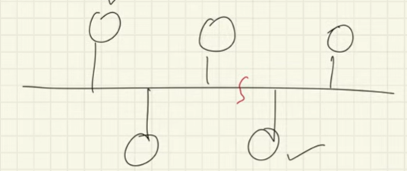

1. RING – every system communicates with one another

* If 1 cable breaks you cannot transfer data
* Lots of calls being made to other devices

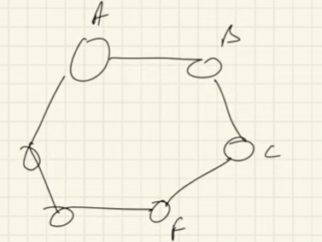

1. Star – 1 central (router) device connected to all devices

* If the central system fails your system goes down

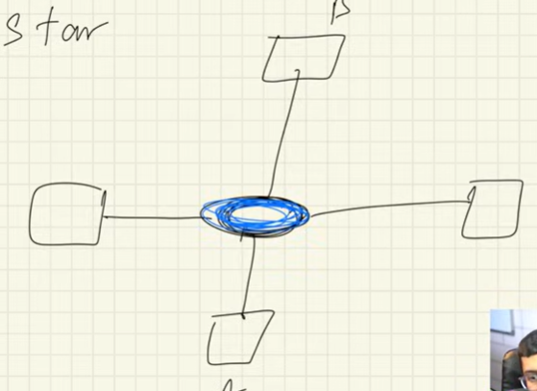

1. Tree (combo of star + bus)

* Many star devices connected in the bus so a bit more fault toleranvce

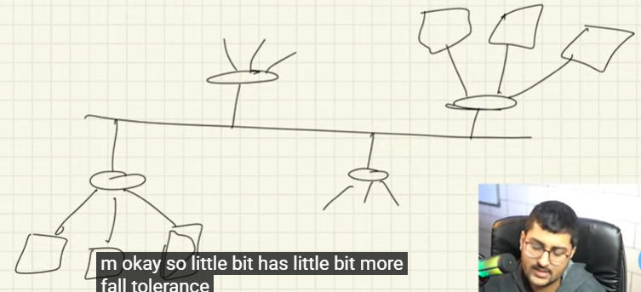

1. Mesh topology – every single computer is connected to every other single computer

* Expensive, so much wire used
* If you want to scale comouters you have to add to connect to everything

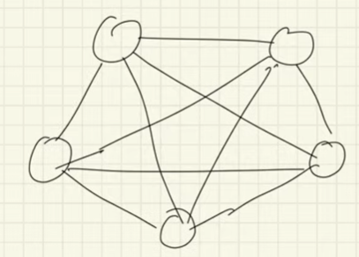

# Structure of the Network

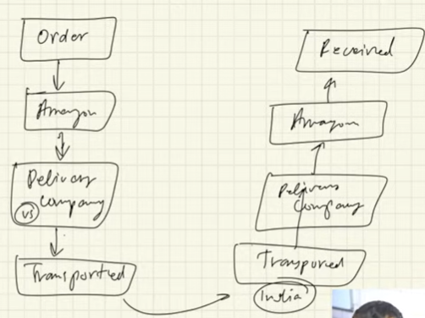 this concept of ordering something from amazon in the us to be transported to your address in India as an example.

THE ORDER AND THE RECEIVED STEPS IS THE APPLICATION LAYER

ALL THE COMPLEXITY BEHIND THAT IS THE INTERNET

## OSI MODEL – Open Systems Interconnection Model (7 layers) important for interviews (MORE CONCEPTUAL BASED)

Develop so that there is a standard way 2 or more devices to communicate with each other. You send a request from a browser and these are the steps they go through to send the request to the server and get the response from the server back to the client it goes in the order 1 to 6 LAYERS

1. APPLICATION LAYER - contains application eg browser
2. PRESENTATION LAYER - encryption & abstraction (assume data is sent downwards and it will be taken down the funnel) & compression & ssl protocol used
3. SESSION LAYER – enables you to know the sending and receiving of data followed by termination of sessions & authentication & authorisation & abstraction
4. TRANSPORT LAYER – TCP or UDP protocol added. Data divided to Segmentation packets which will include a port number and a sequence number to order the packets & flow control to control the amount of data that is being transferred & error control and adding of a checksum to check if the data is true or not.

Everything before is locally on your computer now after this its preparing to send over the internet

1. NETWORK LAYER – Router lives over here, this is for logical addressing – assigning the senders and receivers IP address to every segment to form an IP packet so that every data packet can reach the correct destination. It also performs routing based of IP addresses & subnet masking, routing & load balancing. The routing protocols are helpful in identifying which routing method to use eg Dijkstra’s

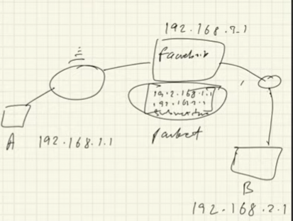

1. DATA LINK LAYER – allows you to directly communicate with the computers and hosts & it does physical addressing – the MAC addresses (Media access control 12-digit alphanumeric number of the NIC of your computer) of the sender and receiver are assigned to the packets to form a frame (a data unit of the data link layer)
2. PHYSICAL LAYER – PHYSICAL router hardware/mechanical layers to transmit the bits from electrical signals to the receiver's point over the internet & order of execution

## ANOTHER MODEL – TCP/IP MODEL – 5 layers (USED MORE PRACTICALLY)

Developed by arpa – Internet Protocol suit. (Application, Presentation and session merged in 1) called Application layer then TRANSPORT LAYER, NETWORK LAYER, DATA LINK LAYER, PHYSICAL LAYER

In the transport layer the data we have is in segments

Only when it gets to the network layer it then becomes Packets

Then the data link layer then makes the frames

Sockets – send messages to another person – it’s the interface between the process and the internet

Ports – how to determine ports HTTP port 80 -Ephemeral ports – uses ports while the ports are running and when they are not being use they are freed up – on the server side they are freed up and internally they can use the internal ports if they know them

* AAPLICATION LAYER -users interact with the application on your device e.g., WhatsApp, browser, protocols any one of these – SMTP, POP3, IMAP, HTTP/S whether you want to GET POST, PUT, DELETE, it is a stateless protocol and uses TCP (transport later) inside it. client-server architecture – they should know how to deal with the request and how to deal with it. The protocols, sockets, ports, error/status codes and cookies, email workings, DNS, URL information

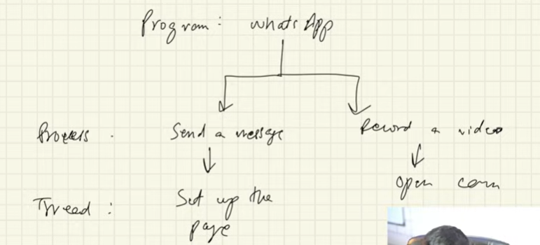

1. TRANSPORT LAYER – layer within the devices – take the data from the network to the applications on the receiver side or form the application to the network on the sender side. Protocol options TCP or UDP – segments packers into sequence number to order the packets & flow control to control the amount of data that is being transferred & error control and adding of a checksum to check if the data is true or not.

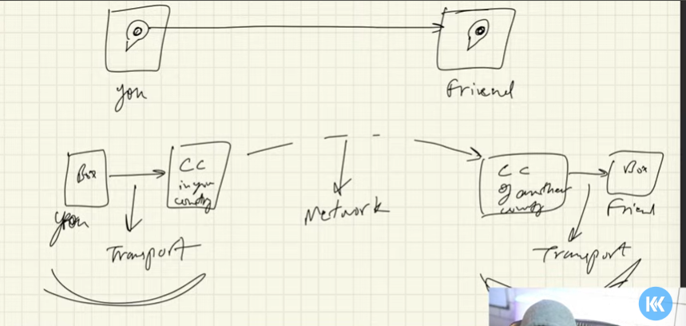

Data travels in packets – transport layers will attach socket, port numbers to packets to know where and to which application to send the data– multiplexing – will allow us to send different file formats of packets to multiple destinations via one medium eg messages file and VC within the multiplex and on the recievers side in the transport layer it will have a De multiplexer which will pass the appropriate data through to the right mediums using Ip addresses, and sockets/gateways within the network with port numbers port numbers. The transport layer also takes care of traffic (congestion control) – congestion control algos are built into the TCP.

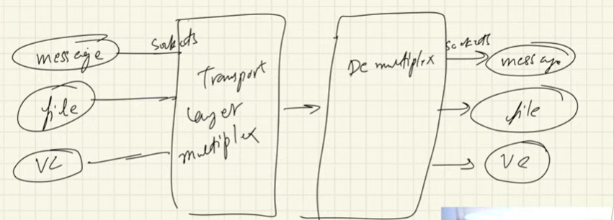

Checksum - Knows if packets were lost using checks sum – like a number – checksum Is a calculated value which is data x algo and then gives an output which is a checksum value. Then send data, reviever will do the same calculations if the calc is correct and checksum is correct then data is correct, if not it is then wrong.

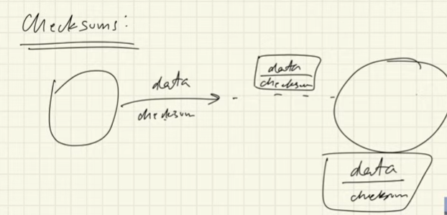

Timers – when the data is sent a timer will be started, if the receiver has received them and confirmation is received then timer stops- if they have been lost and the timer runs out and the friend has not sent the confirmation, then the data system will know that some packets have been lost and the timer will expire and then the same packet will ty to be retransmitted

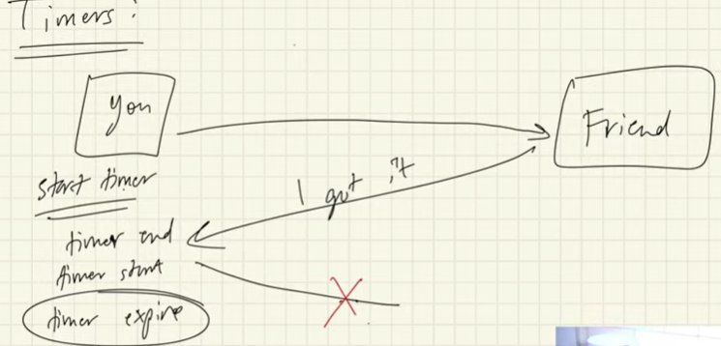

BUT: sequence numbers solve duplicates where the confirmation received is not sent back yet. So it will compare sequence numbers and if theres 2 sequence numbers then its a duplicate

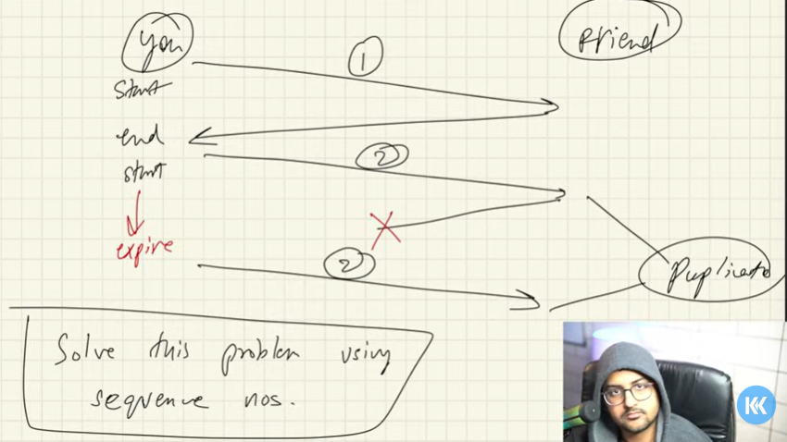

UDP user datagram protocol:

Used to pass data from application to network layer and from network layer to application layer – but the problems is that data may not be delivered or data may change or data may not be in order. THIS IS A CONNECTION LESS PROTOCOL ie no connection established between the 2 devices. UDP uses checksums – but if they are not correct it doesn’t matter. Use it because it is faster, perfect for video calls even if there is loss of quality

UDP packets – will have all of the above previous to the udp heading + will have a source port number and destination port number in a pacjket available – the length of datagram and there will be a checksum (all this is your header) then your data – so your total data would be

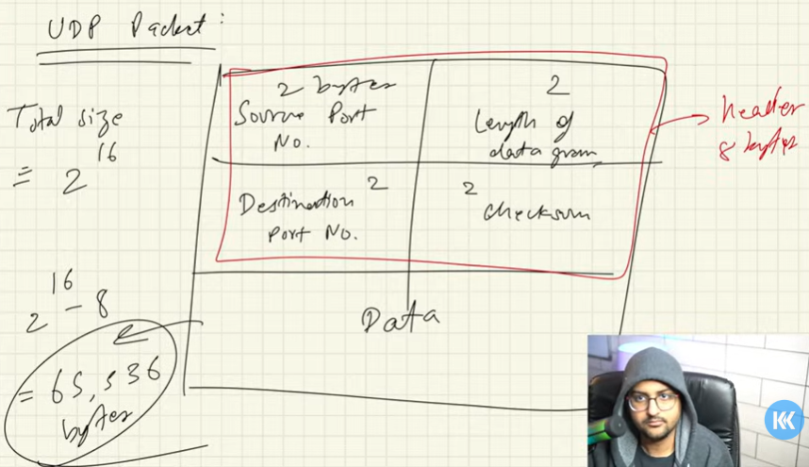

Total data you can send in 1 packet = 2^16 – header which is 8 bytes

DNS use cases of UDP – very fast, video conferencing apps, DNS uses UDP coz very fast, gaming uses UDP

Sudo tcpdump -c 5 to only show last 5 packets

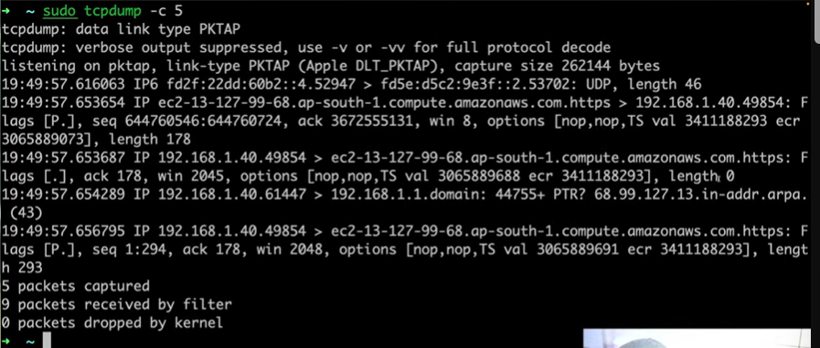

TCP transmission control protocol;:

* Taking data from transport to network and from network to transport – transport layer protocol
* Application layer sends lots of raw data – TCp segments this data – divide into packets – adds header etc all the above before UDP – it also collects the data network layer
* Does congestion control aswell – takes care of when data does not arrive, maintains the sequencing order of data using sequence numbers

Features

* Makes sure there is a connection established between devices first before sending data - then sending synchronisation flag with a random sequence number (for security). Receiver sends syncronisation with acknowledgement with seq numer , thank you I will begin sending the data called the 3 way handshake

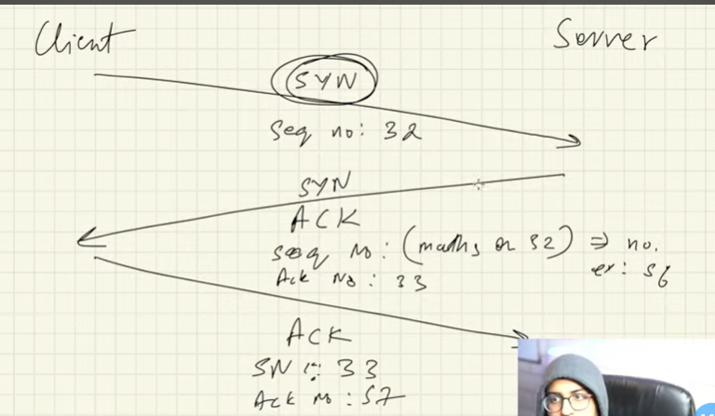

* Error control
* Congestion control
* Full duplex – 2 computers connected 2 each other from A to B and you can both send files simultaneously to each other – can only be 2 endpoints for each tcp connection

1. NETWORK LAYER - Protocols – IP

Here we work with Routers that have many other routers connected to each other. Every router has its own Network Address allow us to send the data packets to check in its routing table or forwarding table to check every destination address – or the ROUTING TABLE will contain source address destination address and the forwarding table will identify the destination address and use hop-by-hop routing to route the packet to go to the appropriate address to the next router till it reaches its right destination which happens over ISP providers

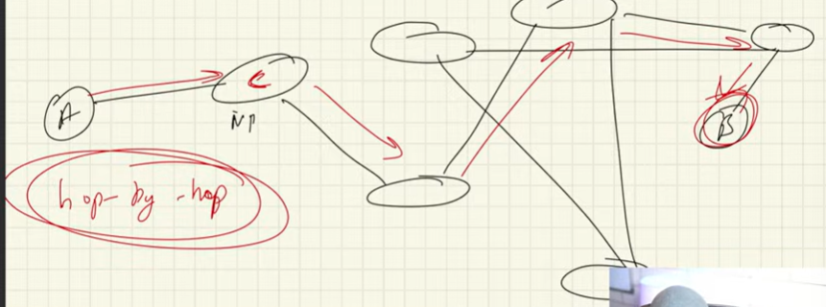

IP address - 192 . 168. 2. 30

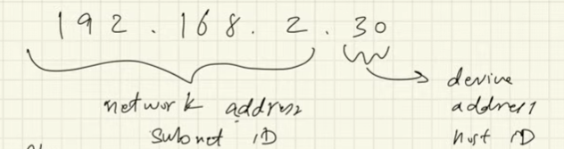 this is called subnetting masking – subnet has the subnet which contains the newtwork address for that specific router and also the host id which contains the device within that specific routers local network

Who creates and adds the routing tables where does it come from – CONTROL PLANE – used to build the routing tables (like a graph) so routers are nodes then the links between routers are the edges:

-1 - Static Routing – adding routing addresses manually

-2 - Dynamic Routing – evolves accordingly with change in algorithms – using Dijkstra

Protocols – IP (internet protocol )addresses : - uniquely defines a server, client, node or a router

IPv4 – 2^32 bits = 4.3 billion so 32 bit numbers with 4 words eg 5 . 6. 9. 14 these are each 8 bit numbers x 4 = 32 bits 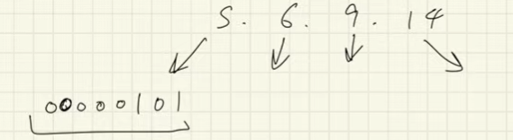 but now this can run out

IPv6 – 128bit numbers with 6

Classes of IP addresses

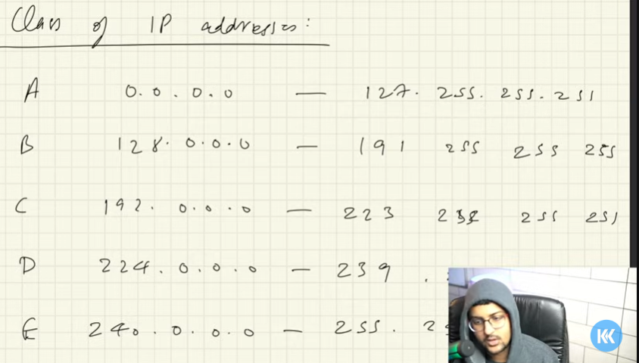

Subnet masking – the mask the network part of the ip address and leaves us to use the host id part – eg CLASS E is usually for 255 . 255 . 0 .0 – to beable to tell which categority it belongs to

Variable length subnet – you can set your own length of the subnet network – eg

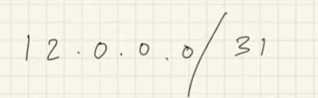 eg 31 bits are my subnet part and the remaining 1 is mine to allocate to my local devices because I have 32 bits in a IPv4 so

If you look at it in binary 8bits .8bits .8bits . 7 bits for subnet and then the remainder 1 bit is for my devices

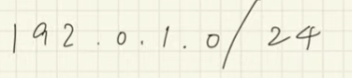 total is 32 bits but 24 bits would not change as they are the subnet id – mine would be the last 8 bits for me to change and allocate to my devices eg 192 . 0. 1. 255 to make a total of 256 = 32 bits

Who allocates ISP IP addresses = THE ITERNET ENGINEERING TASK FORCE – was on a first come first serve basis – IBM, MIT so got allocated class A now with the IETF – they don’t use classes anymore but they assign based on regions

RESERVED IP ADDRESSES = 127 . 0. 0. 0./8 = means the 127 you cannot change but the 0 .0 .0 you can change eg local host is 127.0.0.1 - these are known as loop back addresses -THESE RUN ON YOUR MACHINE using your TCP IP controls ad can allow you to be a client and server at the same time – the system will always be up aslong as your local host device is up and running

PACKETS – header is of 20 bytes containing IP version – total length, ID number, flags protocols, check sum, addresses, etc etc – contains TTL

TTL – time to live = may be that a packet my be stuck in a loop of hops and may not reach the TTL is 60 – so if the packet has been hopping for more than 60 hops it will be dropped with checksum etc

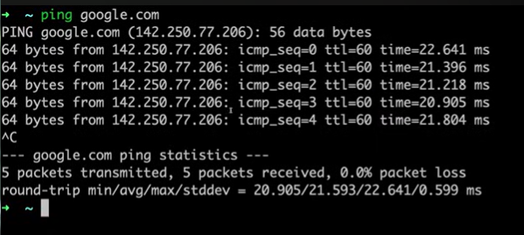

IPv6 = 4 x larger than IPv4 = 2^128 bits = 3.4 x 10^38 numbers

Cons with ipv6 – not backward compatible because its a new tech – devices configured with ipv4 cannot access ipv6 sites because ISPS would have to shift, lots of hardware wor required to shift

There are 8 numbers and each number is a HexDecimal string

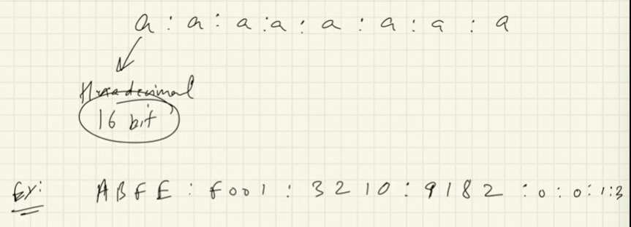

Can also do the same representation with the subnet prefix representation as in the ipv4 and they will be fixed and the rest are for your devices

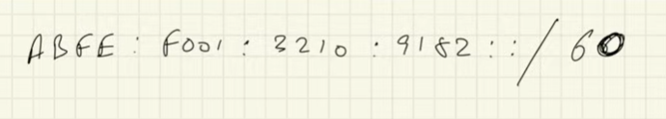

If all values are 0 you can have as just 0

 or 1 : : 9

Middle boxes:

Extra devices that also interact with the packets – also within network and transport layers : Firewall has 2 types Global internet or your trusted network

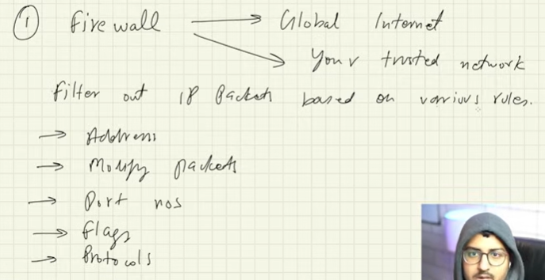

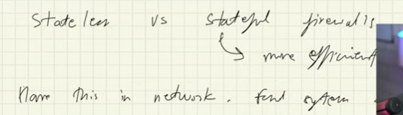

NETWORK Adress Translation –

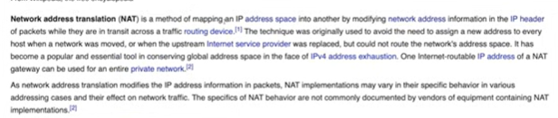

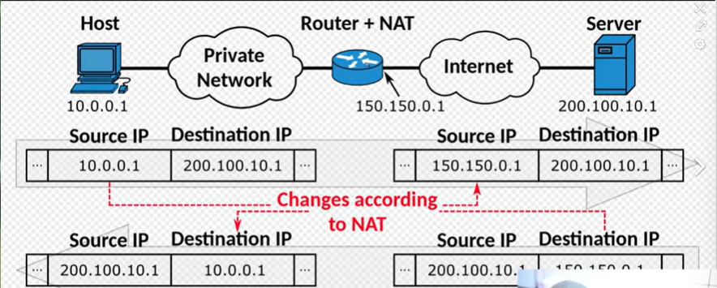

1. DATA LINK LAYER

responsible for sending these packets over a physical link – transport your data between connected devices using DHCP and subnets and how it allocates Ip address with many devices connected in a LAN.

The data link layer addresses this is the MAC ADDRESS OF YOUR DEVICE (whether its your wifi will be different from your Bluetooth )

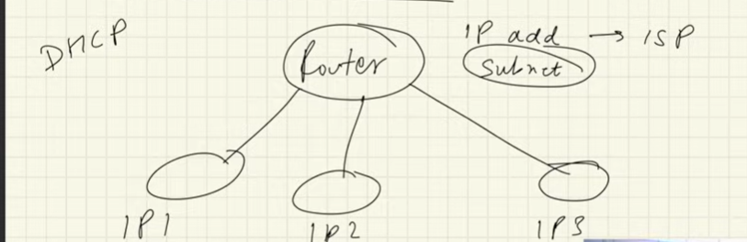

Dynamic Host Communication Protocol – connects your new device to DHCP server to be allocated an IP address from the DHCPs pool of Ip addresses

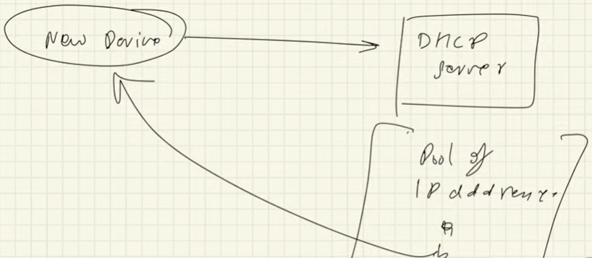

Every device connected in a LAN – will have the data link layer address to addresses in the destination , now device 1 want to send to device 4 within the LAN:

1. Checks its own cache it previously sent there if not
2. Asks in the ARP Address resolution protocol Cache (which all devices in the LAN will receive a message in a frame that will contain a request of the data link layer address (MAC) of sender and Ip address of destination
3. And then it updates the ARP cache and the device 1 will send to device 4

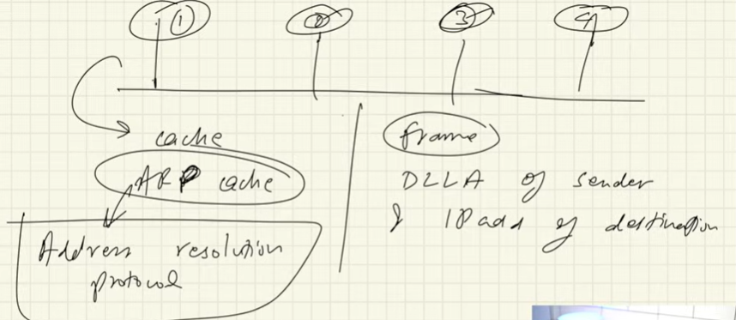

MAC address makes a request and then the data comes back to your router the router will attach the correct private ip address to the data packets ensuring that the router corresponds to the correct device. The private and public Ip address will remain the same but the MAC address of the routers will keep changing from router to router when travelling inside the internet. You can also block certain MAC addresses aswell

Use the command config to check your Mac Address.

Check out framing, error detection

1. PHYSICAL LAYER

Data converted into Electronical signals and gets sent to your devices and hardware,

# KEY TERMS

Repeater, hub, types of hubs (active hub and passive hub), bridge, types of bridge (transparent bridges and source routing bridges), switch, routers, gateways, brouter

